**Create a source storage account in which create a blob container and add some sample data in it.**

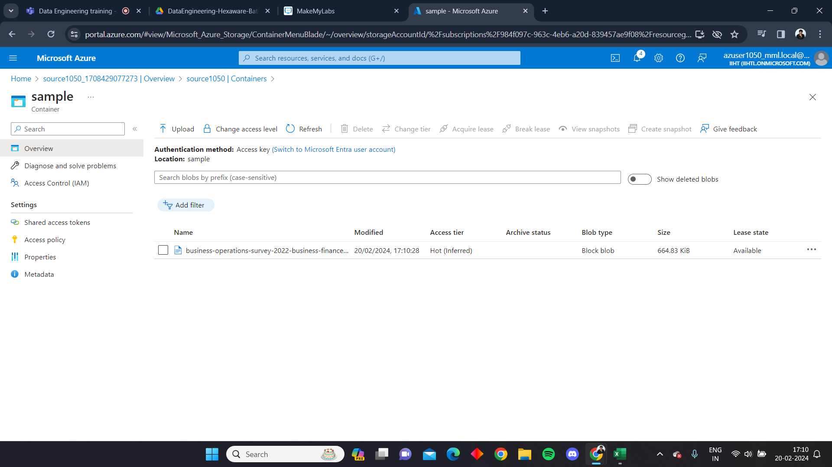

**Create a destination storage account in which just create a blob container.**

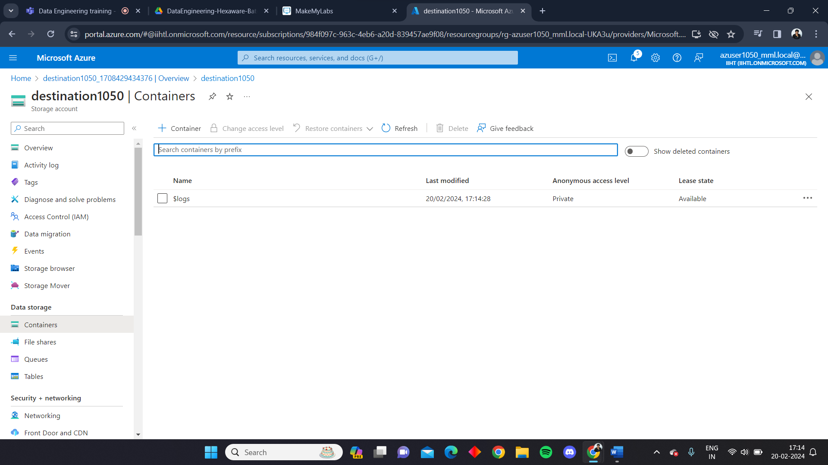

**Create an Azure Data Factory**

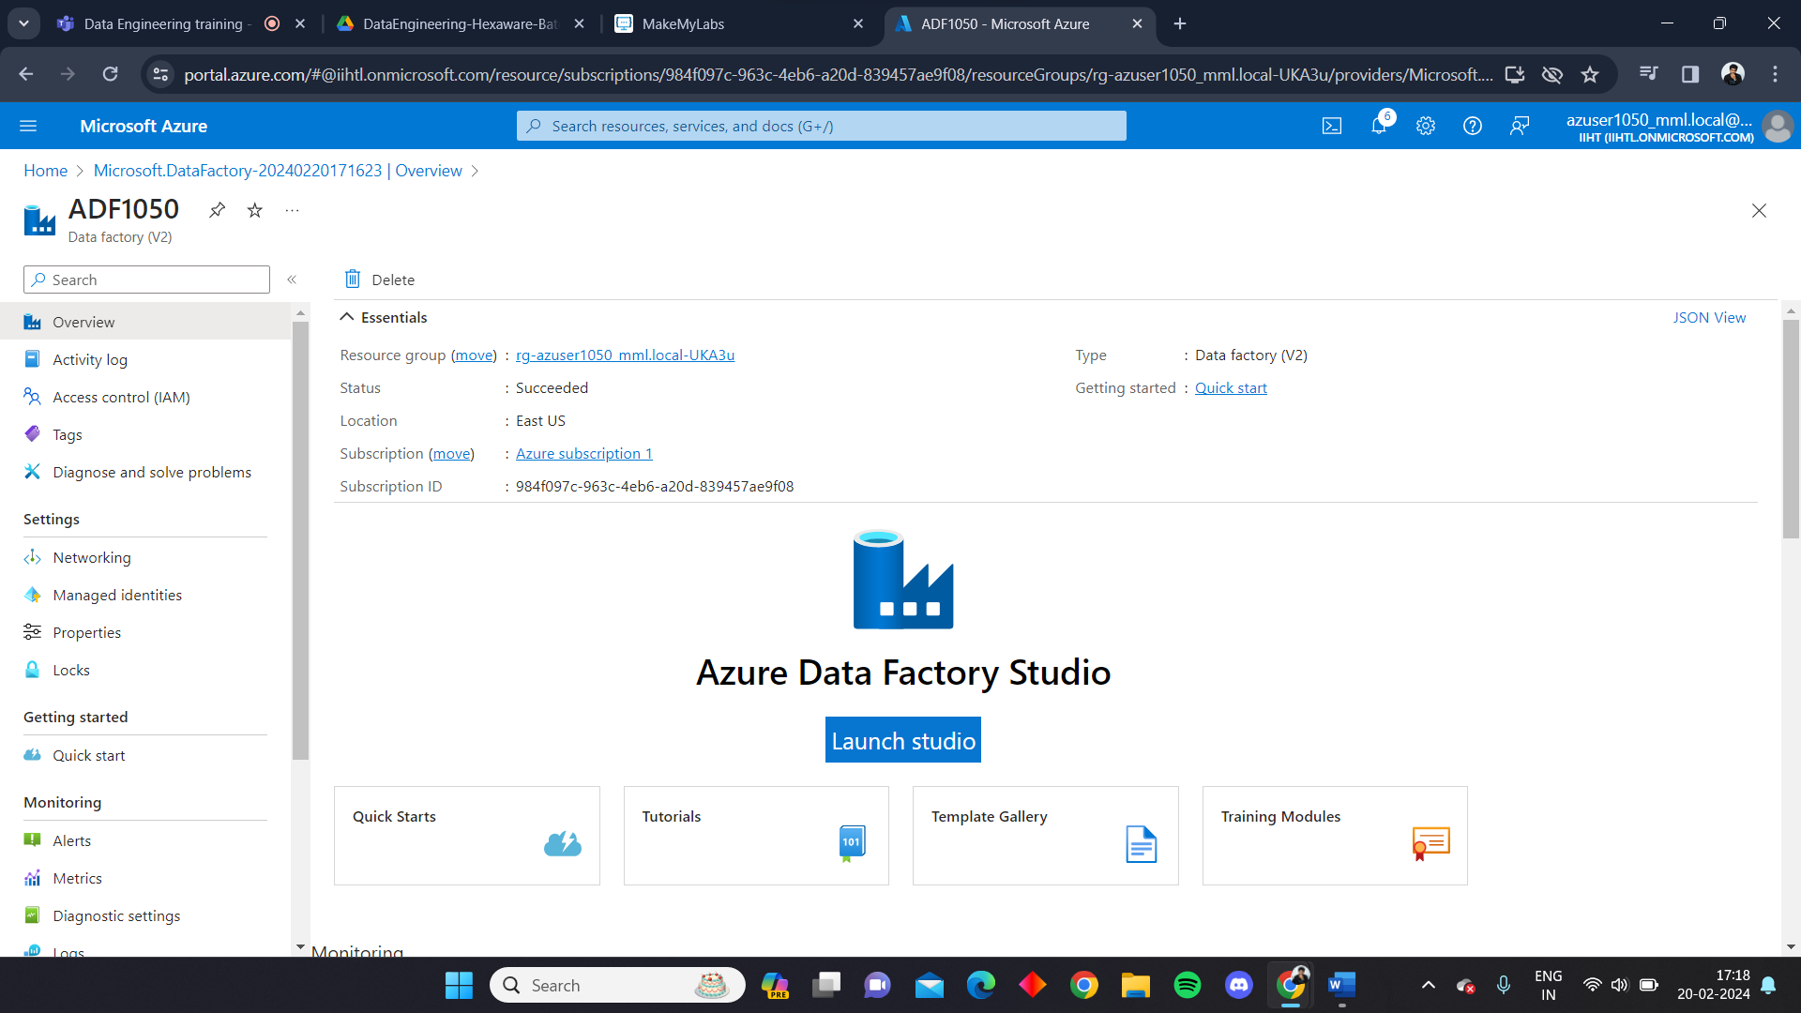

**Perform copy operation using ingest tool and provide the essential source and destination storage account along with the paths**

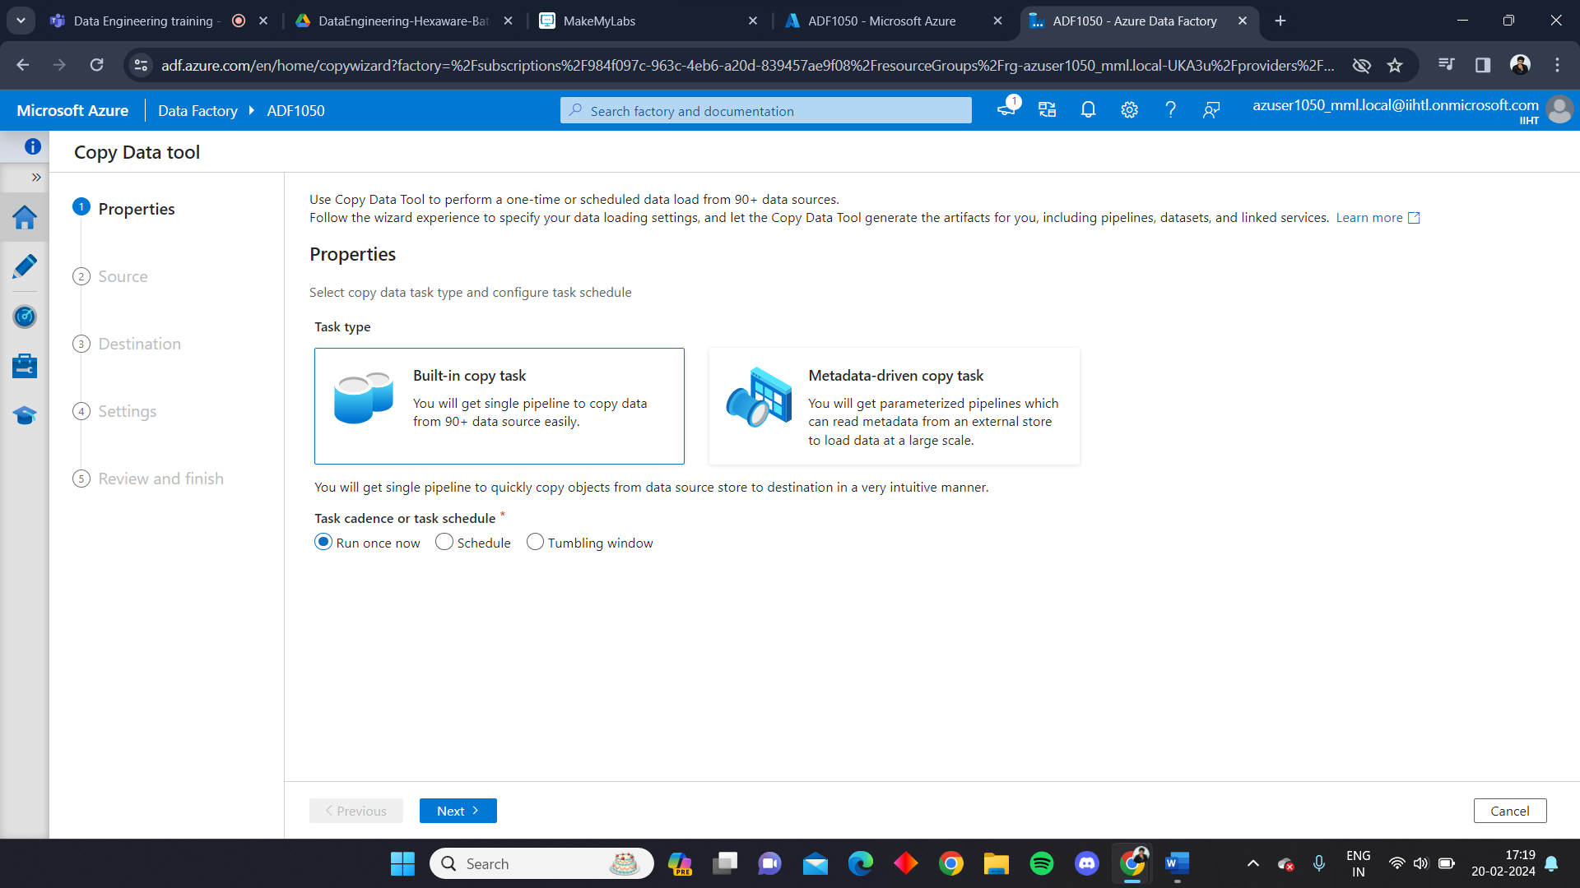

**The data from the source storage account to the destination storage account will be copied through the pipeline.**

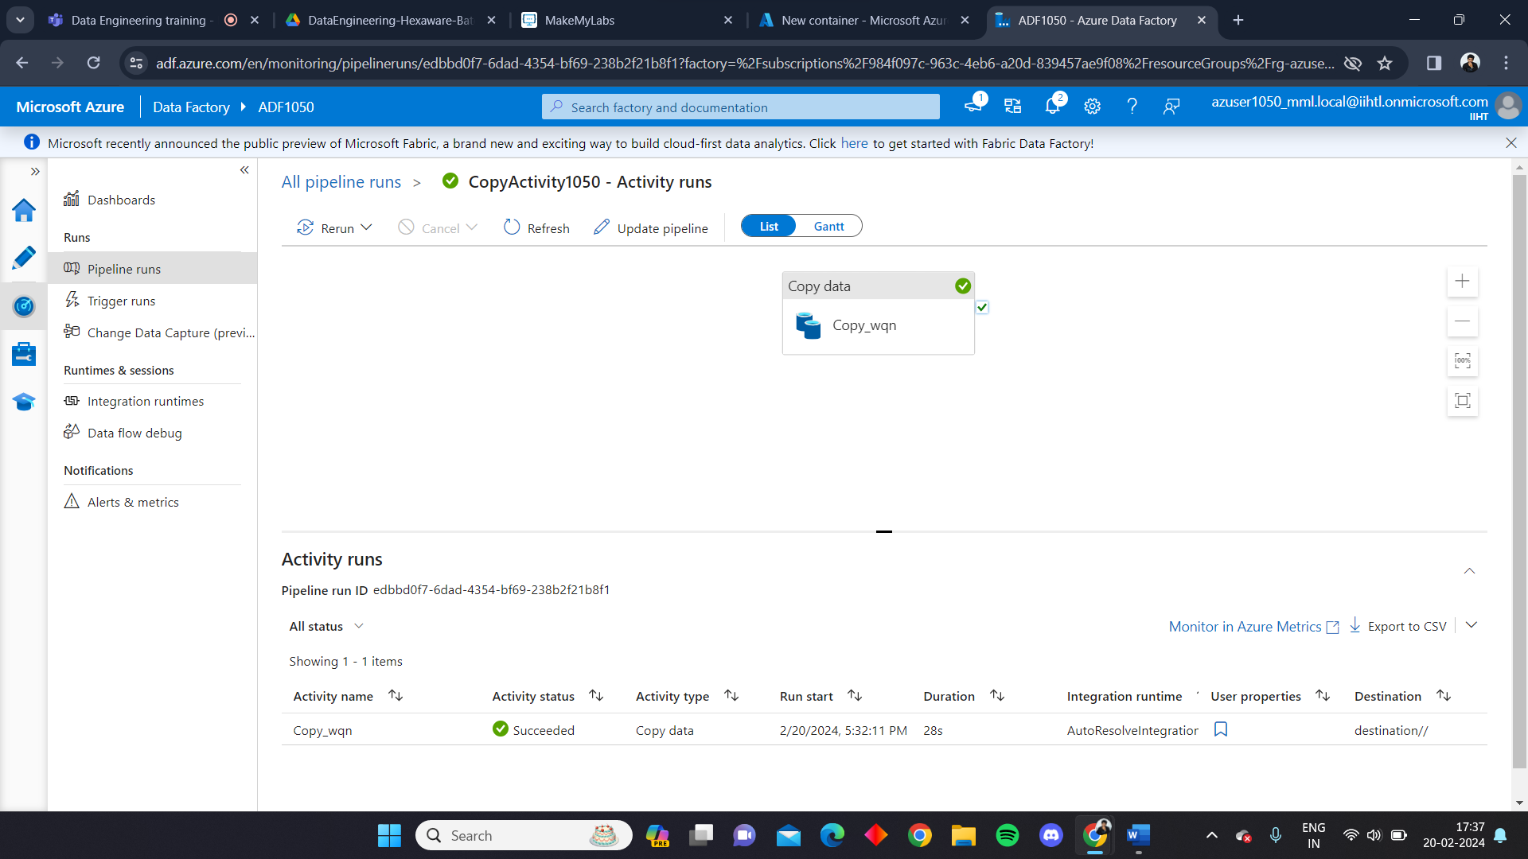

**Once the pipeline is executed we can see that the file present in the source container is copied to the destination container.**

